Introduction to protein structure
- Proteins are polymers of amino acids. Protein structure depends on its amino acid sequence and local, low-energy chemical bonds between atoms in both the polypeptide backbone and in amino acid side chains.
- Protein structure plays a key role in its function; if a protein loses its shape at any structural level, it may no longer be functional.
- Structure of protein is divided into 4 levels of organization: primary secondary, tertiary and quaternary structure.
Primary Structure
- A protein’s primary structure is the unique sequence of amino acids in each polypeptide chain that makes up the protein.
- The common amino acids are α-amino acids. They have a carboxyl group and an amino group bonded to the same carbon atom (the α-carbon). They differ from each other in their side chains, or R groups, which vary in structure, size, and electric charge, and which influence the solubility of the amino acids in water.
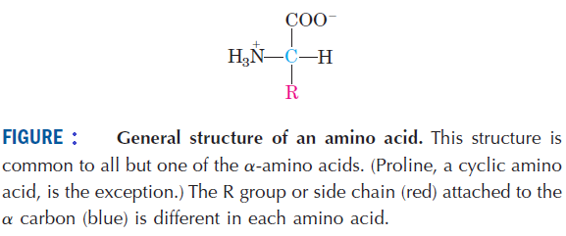
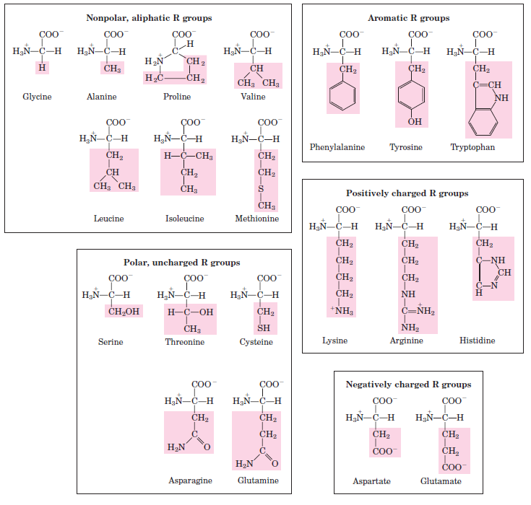
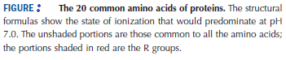
- Two amino acid molecules can be covalently joined through a substituted amide linkage, termed a peptide bond, to yield a dipeptide. Such a linkage is formed by removal of the elements of water (dehydration) from the α-carboxyl group of one amino acid and the α-amino group of another.
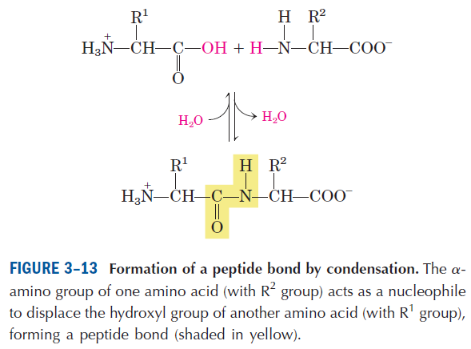

- The peptide bond is rigid and planar. The six atoms of the peptide group lie in a single plane, with the oxygen atom of the carbonyl group and the hydrogen atom of the amide nitrogen trans to each other. The peptide C-N bonds are unable to rotate freely because of their partial double-bond character. Rotation is permitted about the N-Cα and the Cα -C bonds. The backbone of a polypeptide chain can thus be pictured as a series of rigid planes with consecutive planes sharing a common point of rotation at Cα.
By convention, the bond angles resulting from rotations at Cα are labeled Φ (phi) for the N-Cα bond and ψ (psi) for the Cα -C bond. Again, by convention, both Φ and ψ are defined as 180˚ when the polypeptide is in its fully extended conformation and all peptide groups are in the same plane.
In principle, Φ and ψ can have any value between -180˚ and 180˚, but many values are prohibited by steric interference between atoms in the polypeptide backbone and amino acid side chains. The conformation in which both Φ and ψ are 0˚ is prohibited for this reason; this conformation is used merely as a reference point for describing the angles of rotation. Allowed values for Φ and ψ are graphically revealed when ψ is plotted versus Φ in a Ramachandran plot, introduced by G. N. Ramachandran.

